**Image Elastic Registration**

Experimentation and Observation

# Image Registration:

Image registration is the process of aligning two or more images of the same scene taken at different times, from different viewpoints, or by different sensors. The goal of image registration is to find the spatial transformation that best aligns the images so that corresponding features or structures in the images are geometrically matched.

## Approach for Image Registration using ORB and Homography Estimation:

The image registration approach presented in this report utilizes the ORB (Oriented FAST and Rotated BRIEF) feature detection and description algorithm along with homography estimation using the RANSAC (Random Sample Consensus) algorithm. By detecting keypoints, computing descriptors, and finding correspondences between keypoints, the algorithm aligns two images and estimates the spatial transformation required to register them accurately.

### **ORB Feature Detector and Descriptor:**

ORB (Oriented FAST and Rotated BRIEF) is a robust feature detection and description algorithm commonly used in computer vision tasks. It detects keypoints in an image and computes descriptors that represent local features of the image. ORB is particularly efficient and suitable for real-time applications due to its speed and robustness.

### **1.1.2. Brute Force Matcher:**

In this approach, a Brute Force matcher is used to find correspondences between keypoints in the two images. The matcher computes the distance between descriptors of keypoints and finds the best matching keypoints based on this distance metric. By using a brute force approach, all possible matches are considered, making it suitable for small to medium-sized datasets.

### **1.1.3.** **Homography Estimation using RANSAC Algorithm:**

Homography estimation is a common technique used in image registration to compute the transformation between two images. It represents a projective transformation that maps points from one image to another. In this code, the RANSAC (Random Sample Consensus) algorithm is employed to robustly estimate the homography matrix. RANSAC iteratively selects subsets of matched keypoints and estimates the homography matrix using these subsets. It then evaluates the consistency of the model by counting the number of inliers, i.e., matched keypoints that agree well with the estimated transformation. The process is repeated for multiple iterations, and the final homography matrix is determined based on the subset with the maximum number of inliers.

### **1.1.4. Fixed and Moving Images:**

The fixed image is the reference image to which we want to align or register another image. It serves as the base or target image against which the other image is transformed. The fixed image typically remains unchanged during the registration process and provides the spatial context or reference frame for aligning the moving image. The moving image, also known as the source image, is the image that we want to align or register with respect to the fixed image. This image undergoes spatial transformations, such as translation, rotation, scaling, or deformation, to align its features with the corresponding features in the fixed image. The goal is to find the transformation that minimizes the discrepancy between the moving and fixed images, thereby achieving accurate registration. In the provided code, Example1_fixed.tif represents the fixed image, while Example1_moving.tif represents the moving image. The objective is to align the features in the moving image with those in the fixed image through the image registration process.

Input Images:



 Fixed Image

Moving Image

Moving Image

**Results after Image Registration:**

**First result:**



Fixed



Moving

# 2. Results after Image Registration:

# 2.1. First Result:

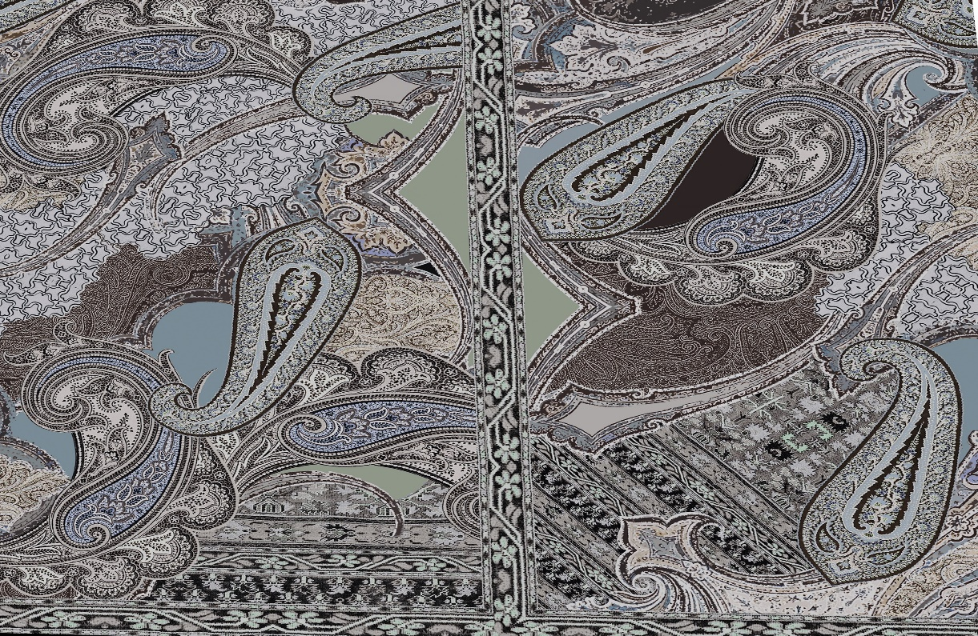

Brute Force Matcher with Hamming Distance:

In the feature matching step, a brute force matcher is employed with the Hamming distance as the measurement mode. The Hamming distance is used specifically when dealing with binary descriptors, such as those generated by the ORB (Oriented FAST and Rotated BRIEF) algorithm. It measures the number of differing bits between two binary strings. This matcher exhaustively compares each descriptor in one set to every descriptor in the other set and selects the one with the smallest Hamming distance as the best match. The choice of the Hamming distance for binary descriptors like ORB is efficient and suitable for matching.

Feature Matching of 5000 Features:

The ORB detector is configured to extract and match 5000 features from each image. Features are distinctive points or regions in the image that can be reliably matched between images. By extracting a sufficient number of features, the algorithm increases the likelihood of finding correspondences between the fixed and moving images, which is crucial for accurate registration.

Reprojection Error:

The reprojection error of 2916 pixels indicates the average discrepancy between the transformed points in the moving image and their corresponding points in the fixed image after applying the computed homography. A lower reprojection error signifies better alignment between the images.

Matching Similarity:

The matching similarity of 0.12 suggests that only a small fraction of the detected features in the moving image have been successfully matched with corresponding features in the fixed image. This metric indicates the quality of feature matching and the effectiveness of the registration process. A higher matching similarity value indicates a better alignment between the images.

## 2.1.1. Second result:



The results indicate an improvement in the image registration process compared to the previous configuration:

**Feature Matching of 10,000 Features:**

The number of features used for matching has been increased to **10,000 per image**. By extracting and matching a larger number of features, the algorithm improves the likelihood of finding accurate correspondences between the fixed and moving images. This increase in feature matching helps in capturing more details and distinctive points, leading to better alignment.

**Reprojection Error Reduced to 1196 Pixels:** The reprojection error, which measures the average discrepancy between the transformed points in the moving image and their corresponding points in the fixed image, has been significantly reduced to 1196 pixels. This reduction indicates that the alignment between the images has improved, resulting in a more accurate registration.

**Matching Similarity Increased to 0.25:** The matching similarity, representing the ratio of successfully matched features to the total number of features detected, has increased to 0.25. This indicates that a larger proportion of features in the moving image have been successfully matched with corresponding features in the fixed image. The higher matching similarity reflects the effectiveness of the feature matching process and the improved registration accuracy.

### 2.1.2. Third result:



**Flann-Based Matcher with Various Distance Metrics:**

In this configuration, the Flann-based matcher is employed with Hamming distance2, Norm_L1, and Norm_L2 as measurement modes. The utilization of Flann-based matching provides a more sophisticated approach compared to the brute force method, potentially offering better performance and efficiency in matching large sets of features. Additionally, the use of different distance metrics allows for exploring various similarity measures to find the best matches.

**Feature Matching of 10,000 Features:**

A larger number of features (10,000) are extracted and matched between the images. This increase in feature matching capacity enhances the likelihood of finding accurate correspondences and improves the overall alignment accuracy.

**Significant Reduction in Reprojection Error:**

The reprojection error, which measures the average discrepancy between the transformed points in the moving image and their corresponding points in the fixed image, has been dramatically reduced to 0.107 pixels. This exceptionally low value indicates a high degree of accuracy in the image alignment, with minimal distortion or misalignment between the registered images.

**Achievement of Matching Similarity of 0.29:** While the matching similarity of 0.29 demonstrates a notable improvement compared to previous configurations, there is still room for enhancement.

# 2.1.3. Second Image Results:



**Findings pertinent to the 2nd Image:**

Our algorithm encountered difficulties in finding sufficient overlap between the two images, potentially due to several factors. Firstly, the presence of geometric distortions, such as perspective distortion or lens distortions, in one or both of the images may have hindered the alignment process. Additionally, differences in perspective or illumination between the two images could have made it challenging to identify consistent feature correspondences across the images. These discrepancies may have resulted in a lack of distinctive key points and hindered the accurate matching of features, ultimately impeding the registration process.

**Future Improvements:**

Experiment with different parameters such as the number of features detected, matching criteria thresholds, and RANSAC algorithm parameters. Fine-tuning these parameters can lead to better feature matching and more accurate homography estimation. Explore alternative feature detection and matching algorithms beyond ORB and Brute-Force matcher. Algorithms like SIFT, SURF, AKAZE, or FLANN-based matchers may provide better results depending on the characteristics of your images. Apply pre-processing techniques such as image resizing, noise reduction, and histogram equalization to enhance the quality of input images and make them more conducive to feature detection and matching. Besides homography estimation, consider using other geometric transformation models like affine transformation or thin-plate spline (TPS) transformation, especially if the scenes exhibit non-linear distortions or significant perspective changes. Consider leveraging deep learning-based approaches for feature extraction and matching, such as convolutional neural networks (CNNs) or Siamese networks, which have shown promising results in image registration tasks.